**What is type casting in C++ and what are the two main types?**

Type casting refers to the conversion of one data type to another in a program. Typecasting can be done in two ways: automatically by the compiler and manually by the programmer or user. Type Casting is also known as Type Conversion.There are two main types:

**Implicit Type Casting:**

* It is known as the automatic type casting.
* It automatically converted from one data type to another without any external intervention such as programmer or user. It means the compiler automatically converts one data type to another.
* All data type is automatically upgraded to the largest type without losing any information.
* It can only apply in a program if both variables are compatible with each other.

**Explicit Type Casting:**

* It is also known as the manual type casting in a program.
* It is manually cast by the programmer or user to change from one data type to another type in a program. It means a user can easily cast one data to another according to the requirement in a program.
* It does not require checking the compatibility of the variables.
* In this casting, we can upgrade or downgrade the data type of one variable to another in a program.
* It uses the cast () operator to change the type of a variable.

**Explain the difference between implicit and explicit type casting.**

|  |  |
| --- | --- |
| **Implicit Type Casting** | **Explicit Type Casting** |
| Done automatically by the compiler | Manually specified by the programmer |
| Easier, as no special syntax is required | Requires specific casting syntax |
| Assigning smaller types to larger types | Converting incompatible or unrelated types |
| |  | | --- | | Generally safer, less prone to errors | | Higher risk of errors if not done carefully |
| Less control over how the conversion is done | Full control over the conversion process |
| ‘int a = 5; double b = a;’ | ‘double a = 3.14; int b = static_cast<int>(a);’ |

**When would you use implicit type casting in C++?**

Implicit type casting in C++ is typically used in situations where the compiler can safely perform the conversion without losing data or precision. Implicit casting is commonly used:

**1.** **Primitive type conversions:** Implicit casting converts between basic types like int, float, char, and bool without losing data.

* + int to float
  + char to int
  + bool to int

**2.** **Assigning a value to a variable:** When assigning a value to a variable, the compiler automatically converts the type to match the variable's type.

* + int x = 5.5; (double to int)
  + float f = 3; (int to float)

**3. Function arguments:** When passing arguments to a function, the compiler converts the argument type to match the function's parameter type.

void func(int x) { ... }; func(5.5); (double to int)

**4. Return types:** When a function returns a value, the compiler converts the return type to match the function's return type.

int func() { return 5.5; } (double to int)

**5. Arithmetic operations:** During arithmetic operations, the compiler converts the types of the operands to a common type to perform the operation. For example, adding an int and a double value, where the int is converted to a double.

int x = 5 + 3.5; (double to int)

**How can you explicitly cast an integer to a float in C++?**

In C++, functional cast (float(x)), static cast (static_cast<float>(x)), and C-style cast ((float)x) are three explicit casting methods that convert a value of one type to another, with static cast being the most recommended for its type safety and readability. you can explicitly cast an integer to a float using the following methods:

**1. Static Cast:**

int x = 5;

float y = static_cast<float>(x);

**2. C-Style Cast:**

int x = 5;

float y = (float)x;

**3. Functional Cast:**

int x = 5;

float y = float(x);

**What are the potential risks associated with explicit type casting?**

**1. Data Loss:** Casting a value to a smaller data type can result in loss of precision or truncation.

**2. Unexpected Behavior**: Casting between unrelated types can lead to unexpected behavior, as the compiler may not be able to perform the conversion as intended.

**3. Runtime Errors:** Casting can lead to runtime errors, such as null pointer exceptions or out-of-range values.

**4. Security Vulnerabilities:** Casting can be used to bypass security checks, potentially leading to security vulnerabilities.

**5. Code Readability:** Excessive use of explicit casting can make code harder to read and understand.

**6. Maintenance Issues:** Casting can make code more difficult to maintain, as changes to the code may require updates to casting operations.

**7. Performance Issues:** Casting can lead to performance issues, as the compiler may need to perform additional operations to perform the cast.

**Describe the four different types of explicit casting operators in C++.**

**1. static_cast:** Used for casting between related types, such as casting a derived class to its base class. It performs a compile-time check and ensures that the cast is safe.

static_cast<new_type>(expression)

**2. dynamic_cast:** Used for casting between related types, such as casting a base class to its derived class. It performs a runtime check and returns a null pointer if the cast fails.

dynamic_cast<new_type>(expression)

**3. const_cast:** Used to cast away the constness of a variable, allowing modification of a constant variable.

const_cast<new_type>(expression)

**4. reinterpret_cast**: Used for casting between unrelated types, such as casting an integer to a pointer. It performs a low-level reinterpretation of the bits and is generally used for low-level programming or interfacing with C code.

reinterpret_cast<new_type>(expression)

**When should you use static_cast for type casting?**

You should use static_cast for type casting in the following situations:

**1. Casting between related classes:** When casting a derived class to its base class or vice versa.

**2. Casting between numeric types:** When casting between integer and floating-point types, such as int to float or double to int.

**3. Casting to a base class:** When casting a pointer or reference to a base class type.

**4. Casting to a specific type: When** you want to explicitly cast a value to a specific type, and the compiler can perform the conversion without losing information.

**In what scenario would you use dynamic_cast for type casting?**

You would use dynamic_cast for type casting in the following scenarios:

**1. Polymorphic casting:** When casting a base class pointer or reference to a derived class pointer or reference, and you want to ensure that the object being cast is actually an instance of the derived class.

**2. Checking for a specific type:** When you want to check if an object is an instance of a specific class, and you want to avoid using typeid or type_info.

**3. Safe downcasting:** When you want to cast a base class pointer or reference to a derived class pointer or reference, and you want to ensure that the cast is safe and valid at runtime.

**4. Runtime type checking**: When you want to check the type of an object at runtime, and you want to take different actions based on the object's type.

**Explain the purpose of const_cast and when it might be necessary.**

The purpose of const_cast is to cast away the constness of a variable, allowing modification of a constant variable. It is used to remove the const qualifier from a variable, making it possible to modify a variable that was originally declared as constant.

const_cast is necessary in certain situations, such as:

**1. Legacy code:** When working with older code that doesn't use const correctly, const_cast can be used to cast away the const qualifier and allow modification of a variable.

**2. API compatibility:** When working with APIs that don't use const correctly, const_cast can be used to cast away the const qualifier and allow modification of a variable.

**3. Temporary modification:** When you need to temporarily modify a constant variable, const_cast can be used to cast away the const qualifier, modify the variable, and then cast it back to const.

**4. Specialized classes:** In some specialized classes, such as proxy classes or wrapper classes, const_cast might be used to modify a constant variable.

**What are the dangers of using reinterpret_cast and why should it be used with caution?**

reinterpret_cast is a powerful casting operator in C++ that allows for casting between unrelated types, but it can be dangerous if used improperly. Here are some dangers of using reinterpret_cast and why it should be used with caution:

**1. Loss of type safety:** By casting between unrelated types, reinterpret_cast bypasses the type system's safety checks, potentially leading to undefined behavior.

**2. Pointer aliasing:** reinterpret_cast can create multiple aliases for the same memory location, leading to confusion and errors.

**3. Data corruption**: Casting between types with different sizes or representations can lead to data corruption or truncation.

**4. Undefined behavior:** Using reinterpret_cast can lead to undefined behavior, especially when casting between types that are not related by a casting relationship.

**5. Maintenance and readability issues:** Excessive use of reinterpret_cast can make code harder to read and maintain, as it can obscure the original intent of the code.

**To use reinterpret_cast safely:**

**1. Use it only when necessary:** Only use reinterpret_cast when there's no other way to achieve the desired result.

**2. Understand the types involved:** Ensure you fully understand the types being cast and their representations.

**3. Use static_cast or dynamic_cast when possible**: Prefer using static_cast or dynamic_cast when casting between related types.

**4. Document the cast:** Clearly document the reason for using reinterpret_cast and the potential risks involved.

**Can you cast a pointer to a different data type using explicit casting?**

Yes, you can cast a pointer to a different data type using explicit casting in C++. This is done using the reinterpret_cast operator. However, it's important to be aware that this can lead to undefined behavior if not done carefully.

The reinterpret_cast operator essentially tells the compiler to treat the memory pointed to by the pointer as a different data type, without actually changing the underlying data.

**What happens when casting a larger data type to a smaller one? How can data loss occur?**

When casting a larger data type to a smaller one, the extra bits of the larger type are truncated or discarded, potentially resulting in data loss.

**Data loss can occur in several ways:**

**1. Truncation:** Discarding higher-order bits or precision bits can result in a loss of significant digits or a reduction in the value's range.

**2. Overflow:** Casting a large value to a smaller type can cause overflow, resulting in an incorrect value (e.g., casting a large positive int to a smaller unsigned type like uint8_t).

**3. Underflow:** Casting a small value to a smaller type can cause underflow, resulting in an incorrect value (e.g., casting a small negative int to an unsigned type like uint8_t).

4. Rounding errors: Casting a floating-point value to a smaller type can result in rounding errors, leading to a loss of precision.

**To avoid data loss, it's essential to:**

1. Use appropriate casting operators (e.g., static_cast or reinterpret_cast).

2. Ensure the destination type can represent the original value's range and precision.

3. Use wider types when possible to avoid truncation and overflow.

4. Be aware of the potential risks and consequences.

**How can you check if a type casting operation is successful with dynamic_cast?**

With dynamic_cast, you can check if a type casting operation is successful by checking if the result is a null pointer. Here's an example:

Base* base = new Derived(); // assume Derived is a subclass of Base

Derived* derived = dynamic_cast<Derived*>(base);

if (derived != nullptr) {

// The cast was successful, and derived points to a valid Derived object

} else {

// The cast failed, and derived is a null pointer

}

In this example, dynamic_cast attempts to cast the base pointer to a Derived* pointer. If the cast is successful, derived will point to the Derived object. If the cast fails (e.g., if base is not a Derived object), derived will be a null pointer.

By checking if derived is not null, you can determine if the cast was successful. This is a common way to ensure that the cast was successful and to avoid null pointer dereferences.

**Is there a way to perform type casting without using any casting operators?**

Yes, there are a few ways to perform type casting without using casting operators in C++:

**1. Constructor casting:** Some classes have constructors that take an object of a different type and create a new object of their own type. For example, you can create a std::string object from a const char* using the std::string constructor.

**2. Assignment:** You can assign a value of one type to a variable of another type, and the compiler will perform the necessary conversion. For example, you can assign an int value to a float variable.

**3. Function calls:** Some functions take arguments of a different type and perform the necessary conversion. For example, the std::sqrt function takes a float argument, but you can pass an int value to it and the compiler will perform the conversion.

**4. User-defined conversions:** You can define your own conversion functions or constructors in your classes to perform type casting without using casting operators.

**What are some best practices for using type casting effectively in C++ code?**

**1. Avoid C-style casts:** Instead of using C-style casts (e.g., (Type)variable), use C++ casting operators (e.g., static_cast<Type>(variable)).

**2.Use casting for conversion, not for forcing:** Casting should be used for legitimate conversions, not to force a type mismatch.

**3. Be aware of object slicing:** When casting a derived class to a base class, be aware of object slicing and potential loss of information.

**4.Use dynamic_cast with caution:** Dynamic casting can be slow and may fail. Use it only when necessary and check for null pointers.

**5. Document casting:** Clearly document the reasoning behind casting, especially for complex or potentially risky casts.

**6. Avoid casting between unrelated types:** Casting between unrelated types can lead to undefined behavior. Avoid it whenever possible.

**7. Use const_cast with care:** Const casting can be dangerous, as it bypasses const correctness. Use it only when necessary and with caution.

**8. Consider alternative designs:** Before casting, consider alternative designs that avoid the need for casting, such as using templates or polymorphism**.**

**Create a code example that demonstrates the use of static_cast for performing a calculation.**

#include <iostream>

Using namespace std;

int main() {

// Define a double variable

double d = 3.7;

// Use static_cast to convert double to int

int i = static_cast<int>(d);

// Perform a calculation

int result = i * 2;

// Print the result

cout << "Result: " << result << endl;

return 0;

}

This code example demonstrates the following:

1. Define a double variable d with the value 3.7.

2. Use static_cast to convert the double value to an int, which truncates the decimal part, resulting in i being assigned the value 3.

3. Perform a calculation by multiplying i by 2, resulting in result being assigned the value 6.

4. Print the result to the console using cout.

**Output:**

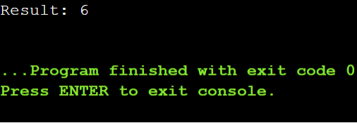

**Write a program that showcases the difference between implicit and explicit casting of integers to floats.**

#include <iostream>

int main() {

int x = 5;

// Implicit casting (automatic conversion)

float y = x;

std::cout << "Implicit casting: " << std::fixed << y << std::endl;

// Explicit casting (using static_cast)

float z = static_cast<float>(x);

std::cout << "Explicit casting: " << std::fixed << z << std::endl;

return 0;

}

**Output:**

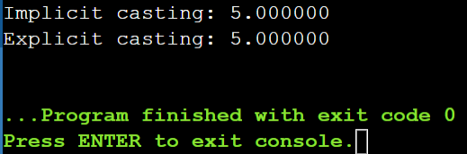

**Simulate a scenario where dynamic_cast is used for checking inheritance relationships between classes.**

#include <iostream>

class Animal {

public:

virtual void sound() = 0;

};

class Dog : public Animal {

public:

void sound() override {

std::cout << "Woof!" << std::endl;

}

};

class Cat : public Animal {

public:

void sound() override {

std::cout << "Meow!" << std::endl;

}

};

int main() {

Animal* animal = new Dog(); // Create a Dog object through Animal pointer

// Check if animal is a Dog

Dog* dog = dynamic_cast<Dog*>(animal);

if (dog != nullptr) {

std::cout << "animal is a Dog" << std::endl;

dog->sound(); // Outputs: Woof!

} else {

std::cout << "animal is not a Dog" << std::endl;

}

animal = new Cat(); // Create a Cat object through Animal pointer

// Check if animal is a Cat

Cat* cat = dynamic_cast<Cat*>(animal);

if (cat != nullptr) {

std::cout << "animal is a Cat" << std::endl;

cat->sound(); // Outputs: Meow!

} else {

std::cout << "animal is not a Cat" << std::endl;

}

return 0;

}

In this scenario:

We have an Animal base class with a virtual sound() method.

Dog and Cat classes inherit from Animal and implement the sound() method.

In main(), we create objects of Dog and Cat through an Animal pointer.

We use dynamic_cast to check if the animal pointer is pointing to a Dog or Cat object.

If the cast is successful (i.e., the pointer is indeed pointing to a Dog or Cat object), we call the sound() method on the casted pointer.

If the cast fails (i.e., the pointer is not pointing to a Dog or Cat object), we print an error message.

**Output:**

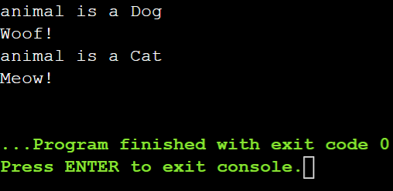

**Discuss situations where using reinterpret_cast might be justified, considering its potential risks.**

using reinterpret_cast might be justified, along with considerations of its potential risks:

**1. Low-level programming:** When working with low-level programming, such as device drivers, embedded systems, or memory-mapped I/O, reinterpret_cast might be necessary to cast between pointer types and integer types.

**2. Serialization and deserialization:** When serializing and deserializing data, reinterpret_cast can be used to cast between pointer types and byte arrays.

**3. Legacy code:** When working with legacy code that uses outdated casting practices, reinterpret_cast might be necessary to maintain compatibility.

**4. Performance-critical code:** In performance-critical code, reinterpret_cast can be used to avoid overhead of virtual functions or runtime type checking.

Risks:

**1. Undefined behavior:** Using reinterpret_cast can lead to undefined behavior if the cast is not valid.

**2. Type punning**: reinterpret_cast can be used to perform type punning, which can lead to unexpected behavior.

**3. Loss of type safety**: reinterpret_cast bypasses type safety checks, which can lead to errors.

**4. Maintenance and debugging:** Code using reinterpret_cast can be harder to maintain and debug.

**Compare and contrast type casting with type conversion in**

Type casting and type conversion are related but distinct concepts in programming:

**Type Casting:**

* + Explicitly forces a value of one type to be treated as another type
  + Does not change the underlying value or memory representation
  + Only changes the interpretation of the value
  + Typically uses casting operators (e.g., static_cast, dynamic_cast, reinterpret_cast)

**Type Conversion:**

* + Changes the underlying value or memory representation from one type to another
  + Creates a new value or object with a different type
  + Can involve data loss or transformation (e.g., truncation, rounding)
  + Often implicit (automatic) or explicit (using conversion functions or constructors)

#include <iostream>

#include <vector>

#include <algorithm>

int main() {

// 1. Construction

std::vector<int> vec1; // Default constructor

std::vector<int> vec2(10, 5); // Fill constructor (10 elements with value 5)

std::vector<int> vec3{1, 2, 3, 4, 5}; // Initializer list constructor

std::vector<int> vec4(vec3.begin(), vec3.end()); // Range constructor

std::vector<int> vec5(vec3); // Copy constructor

std::vector<int> vec6(std::move(vec5)); // Move constructor

// 2. Assignment

vec1 = vec2; // Copy assignment

vec1 = std::move(vec2); // Move assignment

vec1 = {10, 20, 30}; // Initializer list assignment

// 3. Element Access

std::cout << "Element at index 1: " << vec1[1] << std::endl; // Operator[]

std::cout << "Element at index 2: " << vec1.at(2) << std::endl; // at()

std::cout << "First element: " << vec1.front() << std::endl; // front()

std::cout << "Last element: " << vec1.back() << std::endl; // back()

int* data = vec1.data(); // data()

std::cout << "Element via data pointer: " << data[0] << std::endl;

// 4. Iterators

std::cout << "Elements in vec1: ";

for (auto it = vec1.begin(); it != vec1.end(); ++it) { // begin() and end()

std::cout << *it << " ";

}

std::cout << std::endl;

std::cout << "Elements in reverse: ";

for (auto it = vec1.rbegin(); it != vec1.rend(); ++it) { // rbegin() and rend()

std::cout << *it << " ";

}

std::cout << std::endl;

// 5. Capacity

std::cout << "Size: " << vec1.size() << std::endl; // size()

std::cout << "Capacity: " << vec1.capacity() << std::endl; // capacity()

std::cout << "Is empty: " << vec1.empty() << std::endl; // empty()

vec1.resize(5); // resize()

std::cout << "Resized vec1 size: " << vec1.size() << std::endl;

vec1.reserve(20); // reserve()

std::cout << "Reserved capacity: " << vec1.capacity() << std::endl;

// 6. Modifiers

vec1.assign(7, 100); // assign()

vec1.push_back(200); // push_back()

vec1.pop_back(); // pop_back()

vec1.insert(vec1.begin() + 1, 300); // insert()

vec1.erase(vec1.begin() + 2); // erase()

vec1.emplace(vec1.begin(), 400); // emplace()

vec1.emplace_back(500); // emplace_back()

vec1.swap(vec3); // swap()

vec1.clear(); // clear()

// 7. Non-member Functions

std::cout << "Is vec1 == vec3? " << (vec1 == vec3) << std::endl; // operator==

std::swap(vec1, vec3); // swap()

std::cout << "Elements after swap: ";

for (const auto& elem : vec1) {

std::cout << elem << " ";

}

std::cout << std::endl;

// 8. Algorithms

std::sort(vec1.begin(), vec1.end()); // sort()

std::cout << "Sorted elements: ";

for (const auto& elem : vec1) {

std::cout << elem << " ";

}

std::cout << std::endl;

return 0;

}

**Output:**

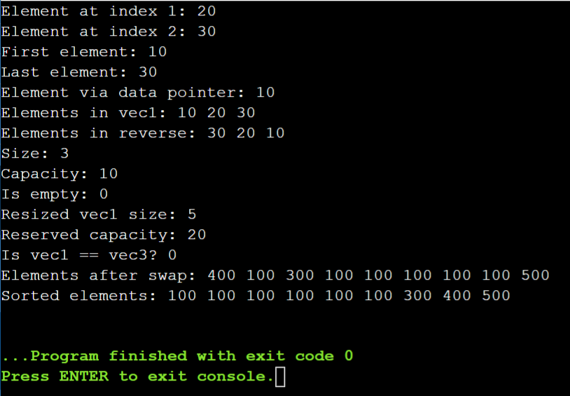

#include <iostream>

#include <vector>

#include <string>

using namespace std;

struct Product {

string name;

double price;

// Constructor

Product(const string& n, double p) : name(n), price(p) {}

};

void printProduct(const Product& product) {

cout << "Product Name: " << product.name << ", Price: " << product.price << endl;

}

int main() {

vector<Product> cart;

// Adding products to the cart

Product apple = {"Apple", 3.99};

cart.insert(cart.begin(), apple);

cart.emplace_back("Banana", 0.79);

// Printing products in the cart

for (const Product& item : cart) {

printProduct(item);

}

return 0;

}

**Output:**

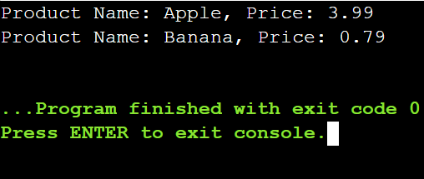

**Imagine you're building a program to manage a list of tasks. Each task is represented by a Task object containing details like description, priority, and due date. You want to add tasks to a vector that stores these Task objects.**

**Challenge:**

**You have two options for adding new tasks:**

**Pre-created Tasks: You might have a pre-defined Task object with all its details set.**

**Creating Tasks on the Fly: You might need to create a new Task object on the fly while adding it to the vector, specifying the details during insertion.**

**Understanding the Difference:**

**insert: Use this if you already have a complete Task object ready to be inserted. insert takes the existing Task object and places it at a specific position in the vector. This might involve copying the object's data.**

**emplace: Use this if you need to create a new Task object with specific details while adding it to the vector. emplace calls the Task constructor directly within the vector's memory, initializing the new object with the provided values. This avoids unnecessary copying.**

#include <iostream>

#include <vector>

#include <string>

#include <algorithm>

struct Task {

std::string description;

int priority;

std::string dueDate;

};

std::vector<Task> tasks;

// Add a pre-created task

void addTask(const Task& task) {

tasks.insert(tasks.end(), task);

}

// Create a task on the fly and add it

void addTask(std::string description, int priority, std::string dueDate) {

tasks.emplace_back(Task{description, priority, dueDate});

}

int main() {

// Add a pre-created task

Task task1{"Complete project", 1, "2024-07-15"};

addTask(task1);

// Create a task on the fly and add it

addTask("Study for exam", 2, "2024-07-20");

// Print tasks

for (const auto& task : tasks) {

std::cout << "Description: " << task.description << std::endl;

std::cout << "Priority: " << task.priority << std::endl;

std::cout << "Due Date: " << task.dueDate << std::endl;

std::cout << std::endl;

}

return 0;

}

**Output:**

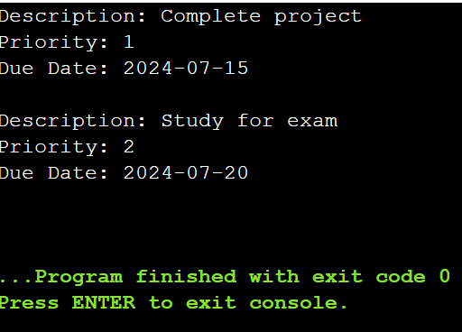

**Design and implement a C++ program that utilizes vectors to efficiently store and manage student exam data. The program should allow for:**

**Adding new students with their names, IDs, and scores.**

**Finding a student by name or ID.**

**Calculating and displaying the average score for a specific student or for the entire class.**

**(Optional) Modifying existing student data (e.g., adding a new score).**

#include <iostream>

#include <vector>

#include <string>

#include <numeric>

using namespace std;

struct Student {

string name;

int id;

vector<double> scores;

double averageScore() const {

if (scores.empty()) return 0.0;

return accumulate(scores.begin(), scores.end(), 0.0) / scores.size();

}

};

void addStudent(vector<Student>& students, const string& name, int id, const vector<double>& scores) {

students.push_back({name, id, scores});

}

Student* findStudentByName(vector<Student>& students, const string& name) {

for (auto& student : students) {

if (student.name == name) {

return &student;

}

}

return nullptr; }

Student* findStudentById(vector<Student>& students, int id) {

for (auto& student : students) {

if (student.id == id) {

return &student;

} }

return nullptr;

}

void displayStudent(const Student& student) {

cout << "Name: " << student.name << ", ID: " << student.id << ", Scores: ";

for (double score : student.scores) {

cout << score << " "; }

cout << ", Average Score: " << student.averageScore() << endl;

}

void displayClassAverage(const vector<Student>& students) {

if (students.empty()) {

cout << "No students in the class." << endl;

return;

}

double totalAverage = 0.0;

for (const auto& student : students) {

totalAverage += student.averageScore();

}

cout << "Class Average Score: " << totalAverage / students.size() << endl;

}

int main() {

vector<Student> students;

// Adding new students

addStudent(students, "Kavya", 101, {90.0, 85.5, 88.0});

addStudent(students, "Rohitha", 102, {78.5, 82.0, 80.0});

string nameToFind = "Kavya";

Student* student = findStudentByName(students, nameToFind);

if (student) {

displayStudent(*student);

} else {

cout << "Student with name " << nameToFind << " not found." << endl;

}

int idToFind = 102;

student = findStudentById(students, idToFind);

if (student) {

displayStudent(*student);

} else {

cout << "Student with ID " << idToFind << " not found." << endl; }

displayClassAverage(students);

return 0;

}

**Output:**

